openEuler内核编程技术

实训指导书

第十三章 第1讲
《 A-Tune 的框架设计与代码分析》

软件所制

术语表
英文 | 中文 | 含义 | 别名
A-Tune |  | 自动AI系统调优工具
Gitee | 码云 | 国内的代码托管协作开发平台

第十三章 第1讲 A-Tune 的框架设计与代码分析

子任务1：编译A-Tune源代码（30mins）

相关知识
- A-Tune介绍
- Tune是一款基于AI开发的系统性能优化引擎，它利用人工智能技术，对业务场景建立精准的系统画像，感知并推理出业务特征，进而做出智能决策，匹配并推荐最佳的系统参数配置组合，使业务处于最佳运行状态。
- Tune已经在openEuler社区开源， 托管在码云Gitee上。
仓库地址: https://gitee.com/openeuler/A-Tune
- A-Tune架构

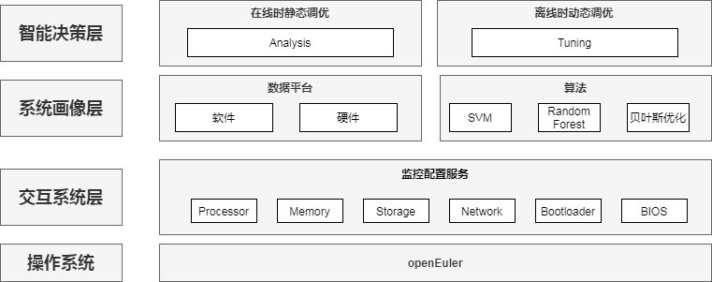
说明：
- 交互系统层： 交互系统层负责A-Tune和系统的监控和配置服务， 包括对CPU， 内存， 网络和磁盘等的监控和配置
- 系统画像层： 系统画像层包括机器学习算法的实现， 也包括软硬件优化参数的存储。
- 智能决策层： 智能决策层是上层逻辑控制层，包括在线时静态调优和离线时动态调优的逻辑控制。

- A-Tune模块
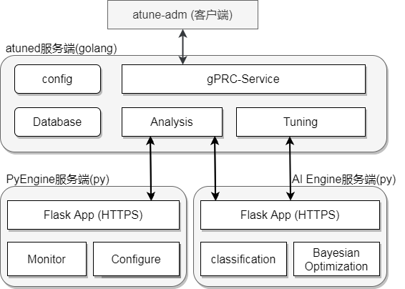
- 客户端： atune-adm
atune-adm是A-Tune的客户端， 也叫client端。 atune-adm负责命令行交互任务， 包括命令行命令的检查和解析， 以及执行结果的显示。
- 服务端： atuned
atuned是A-Tune的服务端, 用golang实现。 负责与客户端atune-adm的交互， 执行命令行命令并返回执行结果。负责静态数据采集和分析的逻辑控制， 负责动态调优过程的逻辑控制。
- 服务端：PyEngine
PyEngine是A-Tune的服务端, 用python实现。负责系统和应用数据的采集， 监控和配置。
- 服务端：AI-Engine
AI-Engine是A-Tune的AI服务端, 用python实现。负责实现A-Tune中的机器学习算法， 并以服务的方式向atuned提供接口用于算法相关的调用。AI-Engine需要实现静态数据分析时的分类算法， 也要实现动态参数调优的搜索算法。
- A-Tune代码分析

文件 | 模块 | 描述
analysis/atuned | PyEngine | PyEngine功能
analysis/engine | AI Engine | 分类算法
analysis/optimizer | AI Engine | 搜索算法
analysis/app_engine.py | AI Engine | AI Engine入口
analysis/app_rest.py | PyEngine | PyEngine入口
api | atune-adm和atuned的接口 | Protobuf接口
cmd/atune-adm | atune-amd | atune-amd功能
cmd/atuned | atuned | atuned功能
common | atune-adm, atuned | 公共库
modules | atune-adm, atuned | 公共库

Atuned的main函数: cmd/atuned/atuned.go
func main() {
app := cli.NewApp()
app.Name = "atuned"
app.Usage = atunedUsage
app.Version = config.Version
app.Before = doBeforeJob
app.Action = runatuned
if err := app.Run(os.Args); err != nil {
fmt.Printf("%s\n", err)
os.Exit(1)
}
}

Atune-adm的main函数: cmd/atune-adm/atune-adm.go
func main() {
app := cli.NewApp()
app.Name = "atune-adm"
app.Usage = usageInfo
app.Version = config.Version
app.Flags = []cli.Flag{
cli.StringFlag{
Name: "address, a",
Usage: "atuned address",
Value: config.DefaultTgtAddr,
},
cli.StringFlag{
Name: "port, p",
Usage: "atuned port",
Value: config.DefaultTgtPort,
},
}
}

PyEngine的main函数: analysis/app_rest.py
def main(filename):
"""app main function"""
app_engine = AppRest()
app_engine.startup_app(filename, "rest_host", "rest_port", "rest_tls",
"tlsrestservercertfile", "tlsrestserverkeyfile", "tlsrestcacertfile")

PyEngine的URI: analysis/app_rest.py
def add_resource(self):
"""flask app add resource"""
self.api.add_resource(configurator.Configurator, '/v1/setting', '/setting')
self.api.add_resource(monitor.Monitor, '/v1/monitor', '/monitor')
self.api.add_resource(collector.Collector, '/v1/collector', '/v1/collector')
self.api.add_resource(profile.Profile, '/v1/profile', '/v1/profile')

AI Engine的main函数: analysis/app_engine.py
def main(filename):
"""app main function"""
EngineConfig.initial_params(filename)
app_engine = AppEngine()
app_engine.startup_app(filename, "engine_host", "engine_port", "engine_tls",
"tlsengineservercertfile", "tlsengineserverkeyfile",
"tlsenginecacertfile")

AI Engine的URI: analysis/app_engine.py
def add_resource(self):
"""flask app add resource"""
self.api.add_resource(optimizer.Optimizer, '/v1/optimizer',
'/v1/optimizer/<string:task_id>')
self.api.add_resource(classification.Classification, '/v1/classification',
'/v1/classification')
self.api.add_resource(train.Training, '/v1/training', '/v1/training')
self.api.add_resource(transfer.Transfer, '/v1/transfer', '/transfer')
self.api.add_resource(detect.Detecting, '/v1/detecting', '/v1/detecting')
self.api.add_resource(ui_tuning.UiTuning, '/v1/UI/tuning/<string:cmd>')
self.api.add_resource(ui_analysis.UiAnalysis, '/v1/UI/analysis/<string:cmd>')
if EngineConfig.db_enable:
from analysis.engine.database import ui_user
self.api.add_resource(ui_user.UiUser, '/v1/UI/user/<string:cmd>')

任务描述
- 了解A-Tune架构和代码组织， 编译A-Tune源代码。
- 从码云Gitee仓库下载A-Tune源代码。
- 阅读A-Tune源代码。
- 阅读Makefile文件, 编译A-Tune源代码。

审核要求
- 正确克隆A-Tune仓库和源码, 按照架构设计和模块划分, 理解A-Tune代码。
- 正确编译A-Tune。
- 提交操作步骤的运行截图。

参考答案
- 环境准备
  - 本地生成SSH公钥
[root@localhost .ssh]# ls
[root@localhost .ssh]# ssh-keygen
Generating public/private rsa key pair.
Enter file in which to save the key (/root/.ssh/id_rsa):
Enter passphrase (empty for no passphrase):
Enter same passphrase again:
Your identification has been saved in /root/.ssh/id_rsa
Your public key has been saved in /root/.ssh/id_rsa.pub
The key fingerprint is:
SHA256:CQtTsi+cFrUIp2kUtU8B8RnjVfyvyRRYflE3Jjn+kUY root@localhost
The key's randomart image is:
+---[RSA 3072]----+
| +o*o* .o. ..+o|
| . = X B . .o+Eo|
| + B B =. o..|
| . . O o .. +..+ |
| = + S +o .|
| . . . .. |
| o o |
| + |
| |
+----[SHA256]-----+
[root@localhost .ssh]# ls
id_rsa id_rsa.pub

  - 访问Gitee主页: https://gitee.com/, 注册Gitee账号
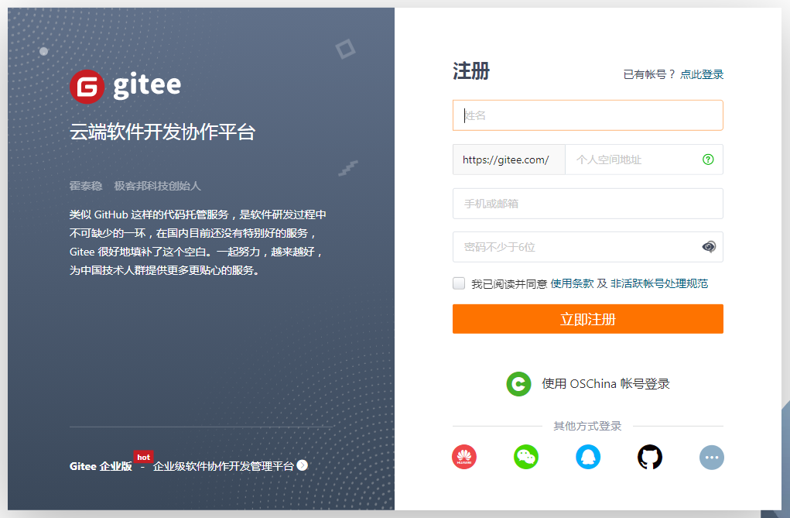
  - 登录Gitee, 点击设置 - 安全设置 - SSH公钥, 添加公钥, 输入本地生成的公钥id_rsa.pub
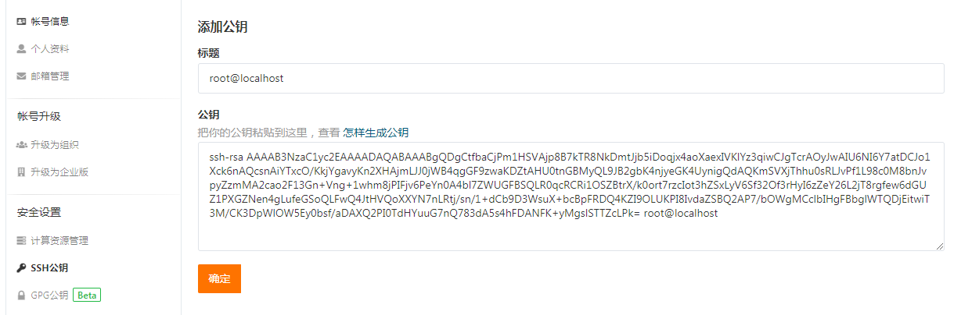
  - 克隆A-Tune项目
访问Gitee上托管的A-Tune项目主页:https://gitee.com/openeuler/A-Tune。
选择”克隆/下载” - SSH, 复制git repo地址: git@gitee.com:openeuler/A-Tune.git
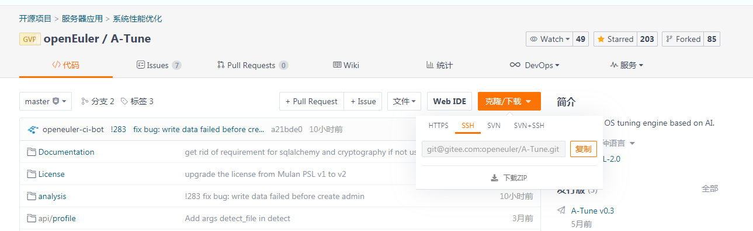
使用git clone命令, 克隆A-Tune项目
[root@localhost src]# git clone https://gitee.com/openeuler/A-Tune.git
Cloning into 'A-Tune'...
remote: Enumerating objects: 2009, done.
remote: Counting objects: 100% (2009/2009), done.
remote: Compressing objects: 100% (849/849), done.
remote: Total 7228 (delta 1139), reused 1802 (delta 1029), pack-reused 5219
Receiving objects: 100% (7228/7228), 109.33 MiB | 6.40 MiB/s, done.
Resolving deltas: 100% (3632/3632), done.

2、编译A-Tune源代码
一、参考答案
（1）列出源代码目录, 执行make编译源代码
[root@localhost A-Tune]# ll -rht
total 152K
-rw-r--r-- 1 root root 13K Feb 5 02:20 Dockerfile-atune-engine
-rw-r--r-- 1 root root 753 Feb 5 02:20 AUTHORS
-rw-r--r-- 1 root root 448 Feb 5 02:20 TODO
-rw-r--r-- 1 root root 5.8K Feb 5 02:20 README-zh.md
-rw-r--r-- 1 root root 6.1K Feb 5 02:20 README.md
-rwxr-xr-x 1 root root 8.2K Feb 5 02:20 Makefile
drwxr-xr-x 2 root root 4.0K Feb 5 02:20 License
drwxr-xr-x 4 root root 4.0K Feb 5 02:20 Documentation
drwxr-xr-x 7 root root 4.0K Feb 5 02:20 analysis
drwxr-xr-x 4 root root 4.0K Feb 5 02:20 cmd
drwxr-xr-x 3 root root 4.0K Feb 5 02:20 api
drwxr-xr-x 2 root root 4.0K Feb 5 02:20 misc
-rw-r--r-- 1 root root 23K Feb 5 02:20 go.sum
-rw-r--r-- 1 root root 793 Feb 5 02:20 go.mod
drwxr-xr-x 3 root root 4.0K Feb 5 02:20 examples
drwxr-xr-x 21 root root 4.0K Feb 5 02:20 common
drwxr-xr-x 2 root root 4.0K Feb 5 02:20 optcfg
drwxr-xr-x 4 root root 4.0K Feb 5 02:20 modules
drwxr-xr-x 4 root root 4.0K Feb 5 02:20 tuning
drwxr-xr-x 3 root root 4.0K Feb 5 02:20 tools
drwxr-xr-x 4 root root 4.0K Feb 5 02:20 tests
drwxr-xr-x 3 root root 4.0K Feb 5 02:20 rules
drwxr-xr-x 17 root root 4.0K Feb 5 02:20 profiles
drwxr-xr-x 7 root root 4.0K Feb 5 02:20 vendor
drwxr-xr-x 2 root root 4.0K Feb 5 03:05 pkg
drwxr-xr-x 2 root root 4.0K Feb 5 03:06 database
[root@localhost A-Tune]# make
cd /root/src/A-Tune/modules/server/profile/ && go build -mod=vendor -v -ldflags '-s -w -extldflags "-static" -extldflags "-zrelro" -extldflags "-znow" -extldflags "-ftrapv" -X gitee.com/openeuler/A-Tune/common/config.Version=0.3(a21bde0)' -buildmode=plugin -o /root/src/A-Tune/pkg/daemon_profile_server.so *.go
go build -mod=vendor -v -ldflags '-s -w -extldflags "-static" -extldflags "-zrelro" -extldflags "-znow" -extldflags "-ftrapv" -X gitee.com/openeuler/A-Tune/common/config.Version=0.3(a21bde0)' -o pkg/atune-adm cmd/atune-adm/*.go
go build -mod=vendor -v -ldflags '-s -w -extldflags "-static" -extldflags "-zrelro" -extldflags "-znow" -extldflags "-ftrapv" -X gitee.com/openeuler/A-Tune/common/config.Version=0.3(a21bde0)' -o pkg/atuned cmd/atuned/*.go
sqlite3 database/atuned.db ".read database/init.sql"

（2）编译完成后的文件列表：
[root@localhost A-Tune]# cd pkg/
[root@localhost pkg]# ll -rht
total 53M
-rw-r--r-- 1 root root 26M Feb 5 03:04 daemon_profile_server.so
-rwxr-xr-x 1 root root 12M Feb 5 03:04 atune-adm
-rwxr-xr-x 1 root root 16M Feb 5 03:05 atuned

子任务2：安装A-Tune(15mins)

相关知识
见1.1中介绍的A-Tune背景知识。

任务描述
- 安装编译完成的A-Tune客户端atune-adm, 以及相关配置文件
- 安装编译完成的A-Tune服务端atuned, AI engine, 以及相关配置文件
- 安装collector模块

审核要求
- 正确安装A-Tune客户端, 服务端,以及相关配置文件。
- 提交操作步骤的运行截图。

参考答案
- 参考答案
- 生成模型
[root@localhost A-Tune]# make models
rm -rf /root/src/A-Tune/analysis/models/*
cd /root/src/A-Tune/tools/ && python3 generate_models.py
the accuracy of random forest classifier is 1.000000
The overall classifier has been generated.
the accuracy of random forest classifier is 1.000000
The application classifiers have been generated.
the accuracy of svc classifier is 1.000000
The application classifiers have been generated.
执行命令: make models
- 安装A-Tune, 客户端, 服务端
执行命令: make install
[root@localhost A-Tune]# make install
BEGIN INSTALL A-Tune...
mkdir -p /usr/bin
mkdir -p /usr/lib/systemd/system
rm -rf /etc/atuned/
rm -rf /usr/lib/atuned/
rm -rf /usr/share/atuned/
rm -rf /usr/libexec/atuned/
rm -rf /var/lib/atuned/
rm -rf /var/run/atuned/
rm -rf /var/atuned/
mkdir -p /etc/atuned/tuning
mkdir -p /etc/atuned/rules
mkdir -p /etc/atuned/training
mkdir -p /etc/atuned/classification
mkdir -p /usr/lib/atuned/modules
mkdir -p /usr/lib/atuned/profiles
mkdir -p /usr/lib/atuned/training
mkdir -p /usr/share/atuned
mkdir -p /usr/libexec/atuned/analysis
mkdir -p /var/lib/atuned
mkdir -p /var/run/atuned
mkdir -p /var/atuned
mkdir -p /usr/share/bash-completion/completions
install -m 640 pkg/daemon_profile_server.so /usr/lib/atuned/modules
install -m 750 pkg/atune-adm /usr/bin
install -m 750 pkg/atuned /usr/bin
install -m 640 misc/atuned.service /usr/lib/systemd/system
install -m 640 misc/atuned.cnf /etc/atuned/
install -m 640 misc/engine.cnf /etc/atuned/
install -m 640 rules/tuning/tuning_rules.grl /etc/atuned/rules
install -m 640 misc/atune-engine.service /usr/lib/systemd/system
install -m 640 database/atuned.db /var/lib/atuned/
install -m 640 misc/atune-adm /usr/share/bash-completion/completions/
\cp -rf analysis/* /usr/libexec/atuned/analysis/
chmod -R 750 /usr/libexec/atuned/analysis/
\cp -rf profiles/* /usr/lib/atuned/profiles/
chmod -R 750 /usr/lib/atuned/profiles/
END INSTALL A-Tune
BEGIN GENERATE REST CERTS...
mkdir -p /etc/atuned/rest_certs
openssl genrsa -out /etc/atuned/rest_certs/ca.key 2048
Generating RSA private key, 2048 bit long modulus (2 primes)
...+++++
...+++++
e is 65537 (0x010001)
openssl req -new -x509 -days 3650 -subj "/CN=ca" -key /etc/atuned/rest_certs/ca.key -out /etc/atuned/rest_certs/ca.crt
openssl genrsa -out /etc/atuned/rest_certs/server.key 2048
Generating RSA private key, 2048 bit long modulus (2 primes)
...........................................................+++++
.................................................................................................................................+++++
e is 65537 (0x010001)
cp /etc/pki/tls/openssl.cnf /etc/atuned/rest_certs
openssl req -new -subj "/CN=localhost" -config /etc/atuned/rest_certs/openssl.cnf \
-key /etc/atuned/rest_certs/server.key -out /etc/atuned/rest_certs/server.csr
openssl x509 -req -sha256 -CA /etc/atuned/rest_certs/ca.crt -CAkey /etc/atuned/rest_certs/ca.key -CAcreateserial -days 3650 \
-extfile /etc/atuned/rest_certs/extfile.cnf -in /etc/atuned/rest_certs/server.csr -out /etc/atuned/rest_certs/server.crt
Signature ok
subject=CN = localhost
Getting CA Private Key
rm -rf /etc/atuned/rest_certs/*.srl /etc/atuned/rest_certs/*.csr /etc/atuned/rest_certs/*.cnf
END GENERATE REST CERTS
BEGIN GENERATE ENGINE CERTS...
mkdir -p /etc/atuned/engine_certs
Generating RSA private key, 2048 bit long modulus (2 primes)
................................................................+++++
...................+++++
e is 65537 (0x010001)
cp /etc/pki/tls/openssl.cnf /etc/atuned/engine_certs
Generating RSA private key, 2048 bit long modulus (2 primes)
........................................................................................................................................................+++++
..+++++
e is 65537 (0x010001)
Signature ok
subject=CN = localhost
Getting CA Private Key
Generating RSA private key, 2048 bit long modulus (2 primes)
...............................................................................+++++
.................................+++++
e is 65537 (0x010001)
Signature ok
subject=CN = localhost
Getting CA Private Key
rm -rf /etc/atuned/engine_certs/*.srl /etc/atuned/engine_certs/*.csr /etc/atuned/engine_certs/*.cnf
END GENERATE ENGINE CERTS
\cp -rf tuning/yamls/* /etc/atuned/tuning
chmod -R 750 /etc/atuned/tuning
cd /root/src/A-Tune/tools/ && python3 generate_tuning_file.py -d /etc/atuned/tuning
- 安装colletor模块
执行命令: make collector-install
[root@localhost A-Tune]# make collector-install
BEGIN INSTALL A-Tune-Collector...
pip3 uninstall atune-collector -y
Found existing installation: atune-collector 0.1
Uninstalling atune-collector-0.1:
Successfully uninstalled atune-collector-0.1
rm -rf collector
git clone https://gitee.com/openeuler/A-Tune-Collector.git collector
Cloning into 'collector'...
remote: Enumerating objects: 291, done.
remote: Counting objects: 100% (291/291), done.
remote: Compressing objects: 100% (143/143), done.
remote: Total 291 (delta 173), reused 249 (delta 146), pack-reused 0
Receiving objects: 100% (291/291), 80.70 KiB | 255.00 KiB/s, done.
Resolving deltas: 100% (173/173), done.
cd collector && python3 setup.py install
running install
running build
running build_py
creating build
creating build/lib
creating build/lib/atune_collector

- 运行结果
- 显示/etc/atuned安装内容
[root@localhost ~]# cd /etc/atuned
[root@localhost atuned]# ll -rht
total 32K
drwxr-xr-x 2 root root 4.0K Feb 5 09:39 training
drwxr-xr-x 2 root root 4.0K Feb 5 09:39 classification
-rw-r----- 1 root root 1.9K Feb 5 09:39 engine.cnf
-rw-r----- 1 root root 3.2K Feb 5 09:39 atuned.cnf
drwxr-xr-x 2 root root 4.0K Feb 5 09:39 rules
drwxr-xr-x 2 root root 4.0K Feb 5 09:39 rest_certs
drwxr-xr-x 2 root root 4.0K Feb 5 09:39 engine_certs
drwxr-x--- 20 root root 4.0K Feb 5 09:39 tuning
- 显示/usr/lib/atuned安装内容
[root@localhost ~]# cd /usr/lib/atuned/
[root@localhost atuned]# ll -rht
total 12K
drwxr-xr-x 2 root root 4.0K Feb 5 09:39 training
drwxr-xr-x 2 root root 4.0K Feb 5 09:39 modules
drwxr-x--- 17 root root 4.0K Feb 5 09:39 profiles

- 显示/lib/systemd/system安装内容
[root@localhost ~]# cd /lib/systemd/system
[root@localhost system]# ll|grep atune
-rw-r----- 1 root root 210 Feb 5 09:39 atuned.service
-rw-r----- 1 root root 215 Feb 5 09:39 atune-engine.service
-rw-r----- 1 root root 208 Jan 30 11:00 atune-web.service

- 显示/bin安装内容
[root@localhost ~]# cd /bin
[root@localhost bin]# ll|grep atune
-rwxr-x--- 1 root root 12M Feb 5 09:39 atune-adm
-rwxr-x--- 1 root root 16M Feb 5 09:39 atuned

- 显示/var/lib/atuned安装内容
[root@localhost ~]# cd /var/lib/atuned/
[root@localhost atuned]# ll
total 56K
-rw-r----- 1 root root 56K Feb 5 09:39 atuned.db

- 显示/usr/local/lib/python3.8/site-packages/atune_collector/安装内容
[root@localhost ~]# cd /usr/local/lib/python3.8/site-packages/atune_collector/
[root@localhost atune_collector]# ll -rht
total 28K
-rw-r--r-- 1 root root 672 Feb 5 10:11 __init__.py
-rw-r--r-- 1 root root 4.2K Feb 5 10:11 collect_data.py
-rwxr-xr-x 1 root root 2.5K Feb 5 10:11 collect_data.json
drwxr-x--- 14 root root 4.0K Feb 5 10:11 scripts
drwxr-xr-x 2 root root 4.0K Feb 5 10:11 __pycache__
drwxr-xr-x 5 root root 4.0K Feb 5 10:11 plugin
[root@localhost atune_collector]# cd scripts/
[root@localhost scripts]# ll -rht
total 48K
drwxr-x--- 2 root root 4.0K Feb 5 10:11 swap
drwxr-x--- 2 root root 4.0K Feb 5 10:11 sched_domain
drwxr-x--- 2 root root 4.0K Feb 5 10:11 rps_cpus
drwxr-x--- 2 root root 4.0K Feb 5 10:11 prefetch
drwxr-x--- 2 root root 4.0K Feb 5 10:11 openssl_hpre
drwxr-x--- 2 root root 4.0K Feb 5 10:11 logind
drwxr-x--- 2 root root 4.0K Feb 5 10:11 ifconfig
drwxr-x--- 2 root root 4.0K Feb 5 10:11 hugepage
drwxr-x--- 2 root root 4.0K Feb 5 10:11 hinic
drwxr-x--- 2 root root 4.0K Feb 5 10:11 hdparm
drwxr-x--- 2 root root 4.0K Feb 5 10:11 ethtool
drwxr-x--- 2 root root 4.0K Feb 5 10:11 blockdev

子任务3：启动和配置 A-Tune (30mins)

相关知识
参见1.1 A-Tune 相关背景知识。
- 部署模式介绍
A-Tune支持单机部署和分布式部署两种模式。本次实训项目， 采用的是单机部署模式， 即A-Tune的客户端， 服务端atuned， 服务端AI engine都部署在同一台机器上。

任务描述
- 启动A-Tune服务端 atuned， 修改配置文件。
- 启动A-Tune服务端 AI engine。
- 启动A-Tune客户端 atune-adm。

审核要求
- 正确启动A-Tune的服务端， 并进行相应的配置。
- 正确启动A-Tune客户端。
- 提交操作步骤和结果的运行截图。

参考答案
一、参考答案
- 启动A-Tune服务端 atuned
执行命令: systemctl start atuned
查看启动结果: systemctl status atuned
[root@localhost ~]# systemctl start atuned
[root@localhost ~]# systemctl status atuned
● atuned.service - A-Tune Daemon
Loaded: loaded (/usr/lib/systemd/system/atuned.service; enabled; vendor preset: disabled)
Active: active (running) since Sat 2021-02-06 05:45:02 UTC; 2s ago
Main PID: 28994 (atuned)
Tasks: 13 (limit: 103332)
Memory: 70.0M
CGroup: /system.slice/atuned.service
├─28994 /usr/bin/atuned
└─29001 python3 /usr/libexec/atuned/analysis/app_rest.py /etc/atuned/atuned.cnf

- 启动A-Tune服务端 AI engine
执行命令: systemctl start atune-engine
查看启动结果: systemctl status atune-engine
[root@localhost ~]# systemctl start atune-engine
[root@localhost ~]# systemctl status atune-engine
● atune-engine.service - A-Tune AI service
Loaded: loaded (/usr/lib/systemd/system/atune-engine.service; enabled; vendor preset: disabled)
Active: active (running) since Sat 2021-02-06 06:44:01 UTC; 8s ago
Main PID: 29899 (python3)
Tasks: 4 (limit: 103332)
Memory: 91.0M
CGroup: /system.slice/atune-engine.service
└─29899 /usr/bin/python3 /usr/libexec/atuned/analysis/app_engine.py /etc/atuned/engine.cnf

Feb 06 06:44:01 localhost systemd[1]: Started A-Tune AI service.
Feb 06 06:44:02 localhost python3[29899]: * Serving Flask app "analysis.app" (lazy loading)
Feb 06 06:44:02 localhost python3[29899]: * Environment: production
Feb 06 06:44:02 localhost python3[29899]: WARNING: This is a development server. Do not use it in a production deployment.
Feb 06 06:44:02 localhost python3[29899]: Use a production WSGI server instead.
Feb 06 06:44:02 localhost python3[29899]: * Debug mode: off

- 修改atuned.cnf配置文件 - 配置监控网卡和磁盘
执行命令ifconfig, 查询当前使用的网卡名称
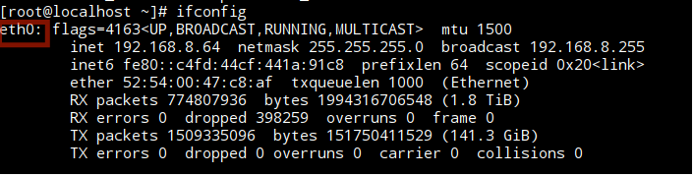

执行命令: fdisk -l, 查询当前使用的磁盘名称
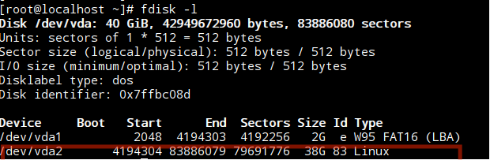

修改配置文件/etc/atuned/atuned.cnf
将网卡名称设置到network字段
将磁盘名称设置到disk字段
[system]
# the disk to be analysis
disk = vda2
# the network to be analysis
network = eth0
user = root

- 启动A-Tune客户端atune-adm
[root@localhost ~]# atune-adm --version
atune-adm version 0.3(a21bde0)

